Section One: Multiple Choice (60 marks)

|  |  |  |  |  |  |
| --- | --- | --- | --- | --- | --- |
| Question | Answer | Question | Answer | Question | Answer |
| 1 | b | 11 | A | 21 | c |
| 2 | A | 12 | a | 22 | A |
| 3 | C | 13 | A | 23 | A |
| 4 | a | 14 | C | 24 | a |
| 5 | b | 15 | B | 25 | b |
| 6 | D | 16 | B | 26 | D |
| 7 | C | 17 | b | 27 | D |
| 8 | D | 18 | C | 28 | A |
| 9 | D | 19 | D | 29 | D |
| 10 | B | 20 | b | 30 | b |

Section Two: Short Answers (100 marks)

**Question 31.**

“Junk food, sugary drinks and insulin may be major players in the onset of Alzheimer’s disease,” screamed the Health and Medicine section of the West Australian in January this year. The article went on to say that studies have shown that Type 2 diabetics have a 50% increased chance of developing dementia. Professor Martins, from the McCusker Alzheimer’s Research Foundation, stated that he had shown in his investigation that amyloid levels build up in response to high insulin levels. The prediction of up to 3 million people developing Alzheimer’s between now and 2050 is now believed to be only half that expected given the observed rise in obesity and Type 2 diabetes levels in this country.

(a) Use the feedback model to describe the way in which high blood glucose would be returned to an optimal level in a healthy person. (6 marks)

*Stimulus – increased blood glucose level (1)*

*Receptor – chemoreceptors / beta cells in islets of Langerhans / pancreas (1)*

*Modulator – beta cells in islets of Langerhans / pancreas (1)*

*Effector – all body cells / liver / skeletal muscle cells (1)*

*Response – glycogenesis / increased absorption of glucose by skeletal muscle cells / body cells (1)*

*Feedback – decreased blood glucose levels (1)*

(b) Explain the effect of Type 2 diabetes on the regulation of blood glucose. (2 marks)

*Type 2 diabetics are able to produce insulin but their body cells do not respond to it (1)*

*Thus blood glucose levels remain higher than optimal / they can’t regulate their blood glucose levels within the optimal range (1)*

(c) Explain the effect of a build up of amyloid in brain tissue. (2 marks)

*(Any 2 marks, 1 mark each)*

*Less acetylcholine is produced (1)*

*Tau / protein tangles occur (1)*

*Onset of Alzheimer’s disease (1)*

(d) What would have been the dependent variable in Professor Martins’ investigation?

(1 mark)

*amyloid levels (1)*

(e) State three symptoms experienced by someone with Alzheimer’s. (3 marks)

*memory loss / withdrawal / aggression / mood swings / confusion arises (Any 3, 1 each)*

(f) A worldwide study starting next year in Perth and other cities around the world will test the effect of insulin sensitising drugs on the incidence of Alzheimer’s.

(i) What hypothesis would they be testing? (1 mark)

*If insulin sensitising drugs are used then the incidence of Alzheimer’s will decrease / increase / remain unchanged (1)*

(ii) The scientists have decided to use a placebo in this study. What is a placebo and what is the advantage of using a placebo in a scientific trial? (2 marks)

*A placebo is an inert substance / protocol given to the control group (1)*

*It reduces the psychological impact of the subjects on the results of the experiment (1)*

(iii) The scientists have also decided to use a double blind trial. What is the main advantage of such a trial? (1 mark)

*Prevents bias from both the scientists and subjects (1)*

(g) Fifty years ago, a drug called thalidomide was given to pregnant women to cure their morning sickness. Soon a causal link between the drug and the number of babies being born without arms and/or legs was identified. In 1998, the United States Food and Drug Administration approved the use of thalidomide to treat leprosy and now scientists are looking to trial it in the treatment of AIDS, tuberculosis and some types of cancer. What ethical criteria must be considered prior to permitting the use of thalidomide for these diseases? (2 marks)

*voluntary participation / informed consent / risk of harm / confidentiality (Any 2, 1 each)*

**Question 32. (5 marks)**

A man arrived home from Bali with what he thought was a big pimple on his right buttock. Unfortunately, it quickly became enlarged, taking up almost the whole of that side of his buttock and began to encroach out onto his thigh. It was hot, red, painful and full of yellow pus that continually oozed out of an open wound at its centre. His wife took him to the doctor when he started suffering raging fever, sweats and chills. The doctor took a sample of the pus, cultured it on a nutrient agar gel in a petri dish with five different types of antibiotics (small circles A, B, C, D and E) and incubated it at 30oC. The dark shaded area shows where the bacteria have grown, while the white circular spaces is where bacteria have not grown.

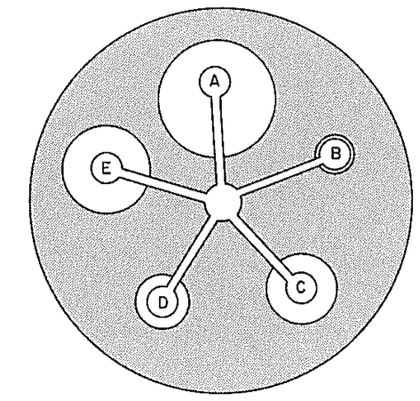

A = penicillin

B = tetracycline

C = tinidazole

D = enoxacin

E = erythromycin

(a) What is an antibiotic? (1 mark)

*A human made / synthetic chemical that kills bacteria / bacteria and fungi (1)*

(b) The man told the doctor he was allergic to penicillin. According to the petri dish shown above, which antibiotic should the doctor give the man? (1 mark)

*Antibiotic E / erythromycin (1)*

(c) The bacteria causing his condition appear to be resistant to one of these antibiotics. According to the petri dish shown above, which one is it resistant to? (1 mark)

*Antibiotic B / tetracycline (1)*

(d) The patient was given an antibiotic to take every day for the following 10 days. The doctor stressed the importance of continuing to take the antibiotics even if the wound started to heal. Why is this? (1 mark)

*To avoid the bacteria building up a resistance to the antibiotic (1)*

(e) At the turn of the century, spider webs containing trapped fungal spores were often placed over minor cuts and wounds. Why would this have been done? (1 mark)

*Fungi produce antibiotics that would have killed any bacteria in the wound (1)*

**Question 33. (9 marks)**

(a) State two (2) means by which humans can lose water. (2 marks)

*As urine / in faeces / sweating / breathing (Any 2, 1 mark each)*

The graph below shows the fluctuations in body fluid over time.

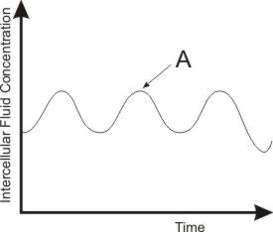

(b) Draw in the optimal intercellular fluid concentration line onto the graph. (1 mark)



*(1)*

(c) State two mechanisms the body might employ at point A on the graph to decrease intercellular fluid concentration. (2 marks)

*decrease ADH production / reduce sensation of thirst (Any 2, 1 each)*

(d) (i) At one point, the person’s fluid levels seem to have dropped outside the normal

range. What might have caused this change? (1 mark)

*increased sweating / increased exercise / increased salt intake / decreased drinking (Any 1, 1 mark)*

(ii) What is the effect of this on their: (3 marks)

water levels in their cells *decreased (1)*

amount of ADH produced *increased (1)*

blood pressure *increased (1)***Question 34. (7 marks)**

In vertebrates, it has been observed that the heartbeat originates in the heart itself.

(a) Name the structure in the heart that is responsible for the origin of the heartbeat.

(1 mark)

*sino-atrial node (1)*

(b) There are two sets of nerves that innervate the heart. Which nerve pathway would cause the heart rate to slow? (1 mark)

*Parasympathetic (1)*

(c) If you are seated and then stand up and start walking, your heart rate increases. What structure in the brain is responsible for this increase in heart rate? (1 mark)

*medulla oblongata (1)*

(d) Heart rate increases during exercise. State two stimuli that occur as a result of exercise that will cause this reaction. (2 marks)

*(Any two of the following, 1 mark each)*

*increased temperature (1)*

*increased carbon dioxide concentration in the blood (1)*

*increased hydrogen ion / decreased pH in the blood (1)*

(e) Besides adrenalin, name two other hormones that would increase heart rate.

(2 marks)

*cortisol / thyroxine / noradrenalin (Any 2, 1 mark each)*

**Question 35. (8 marks)**

The diagram below shows part of the process of gene expression.

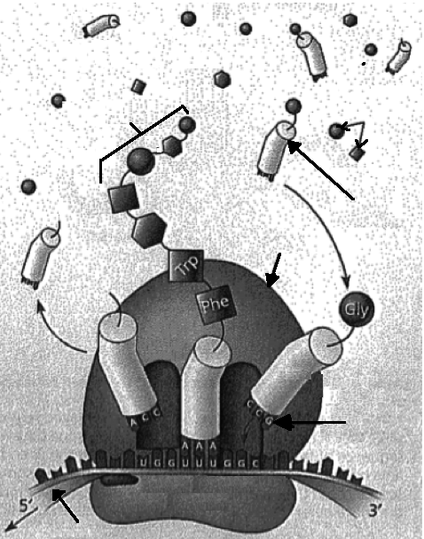

C B

A

D

E

F

(a) What is this part of the process called? (1 mark)

*Translation (1)*

(b) Name the following structures: (4 marks)

A *tRNA (1)* C *polypeptide / protein (1)*

B *amino acids (1)* D *ribosome (1)*

(c) (i) How is structure F similar to DNA? (1 mark)

*contains four nitrogen bases / can be found in the nucleus /*

(ii) How is structure F different to DNA? (2 marks)

*F is made of ribose sugar not deoxyribose sugar like DNA / F is a single strand not double stranded like DNA / F leaves the nucleus while DNA doesn’t / F contains Uracil while DNA contains thyamine (Any 2, 1 mark each)*

**Question 36. (12 marks)**

The diagram below shows the relationship between the hypothalamus, pituitary and the ovary.

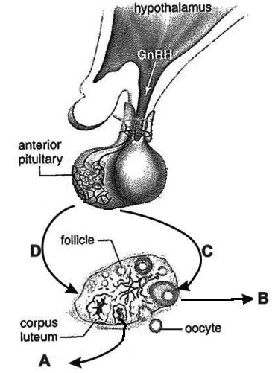

(a) Which hormones do the labels A, B, C and D represent? (4 marks)

A *progesterone / oestrogen (1)*

B *oestrogen (1)*

C *LH / luteinising hormone (1)*

D *FSH / follicle stimulating hormone (1)*

(b) A hormone cascade pathway is one in which the secretions of one endocrine gland cause the secretion of hormones from another endocrine gland. Besides the example shown in the diagram above, state one such hormone cascade pathway, naming the endocrine glands involved and the hormones they release. (2 marks)

*(Any 1 of the following pairs of information, 1 mark each)*

*Hypothalamus produces TSHrf (1)*

*which causes the release of TSH from the anterior pituitary (1)*

*Anterior pituitary produces TSH (1)*

*Which causes the release of thyroxine from the thyroid (1)*

*ACTH from the anterior pituitary (1)*

*Which causes the release of cortisol / aldosterone from the adrenal cortex (1)*

(c) Complete the table below comparing the different categories of hormones. (4 marks)

|  |  |  |
| --- | --- | --- |
|  | Amine based hormone | Steroid based hormone |
| Where receptors can be located | *Only on the cell membrane (1)* | *On cell membrane / in cytoplasm / on organelles / on a named organelle / on the nuclear membrane (Any 1, 1 mark)* |
| Effect on cell activity | *Activate enzymes / changes rate of cell metabolism (1)* | *Activate genes / affect gene expression / produce protiens (1)* |

(d) It is possible to transplant a working pancreas into a patient suffering from Type I diabetes in order to cure the disease. Explain why the use of stem cells to replace the faulty pancreas would be a better option than transplant surgery. (2 marks)

*prevents the issue of rejection (1)*

*as stem cells are recognised as self (1)*

(e) Explain why gene therapy is being considered for Huntington’s chorea and cystic fibrosis but not for changing skin colour. (1 mark)

*Huntington’s chorea and cystic fibrosis are monogenic whilst skin colour is polygenic (1)*

**Question 37. (8 marks)**

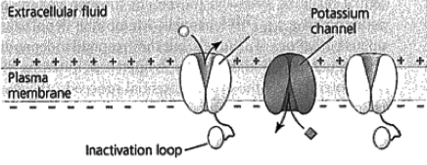

A

The diagram above represents an axon of a nerve cell membrane prior to an action potential occurring.

(a) What substance would be able to pass through structure A when an action potential occurs? (1 mark)

*sodium ions (1)*

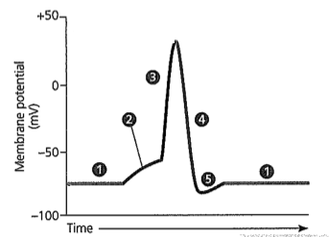

Diagram 2

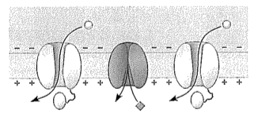

(b) Which part of the action potential shown in the graph above (1, 2, 3, 4, or 5) would Diagram 2 depict? (1 mark)

*3 (1)*

(c) Explain how a sodium potassium pump maintains the level of ions required for a resting nerve cell membrane. (3 marks)

*transports sodium to the outside of the cell (1)*

*transports potassium to the inside of the cell (1)*

*moves more sodium out and less potassium into the cell / moves 3 sodium out for every 2 potassium in (1)*

(d) Ouabain is a substance extracted from an African plant by the Somali people who use it to poison their arrow-heads in order to kill animals. A sufficient concentration of the chemical can bring down a hippopotamus. Scientists now know that ouabain prevents the sodium-potassium pumps in nerve cell membranes from working. In the presence of ouabain, what change would you expect to see in the resting potential of a nerve cell? (1 mark)

*higher resting membrane potential / higher positive potential inside the cell (1)*

(e) State two (2) ways in which the speed of action potentials can be increased.

(2 marks)

*myelin sheath / short distances to travel / wider diameter of axon (Any 2, 1 mark each)***Question 38. (9 marks)**

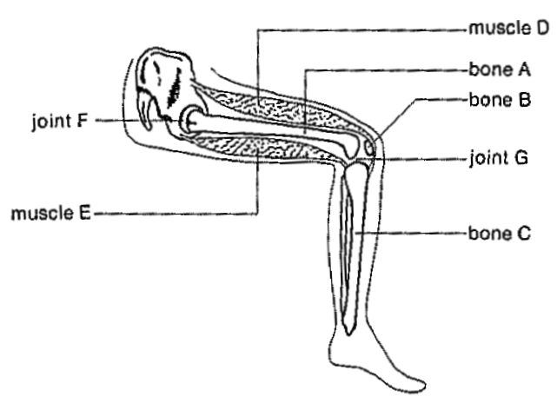

(a) Describe a microscopic characteristic that you would expect to see in muscles D and E that would not be seen in smooth muscle tissue. (1 mark)

*striations / multinucleated (Any 1, 1 mark)*

(b) (i) What will happen to the leg when muscle D contracts? (1 mark)

*lower leg will extend (1)*

(ii) Muscle E is relaxing when muscle D contracts. What is this relationship between the two muscles called? (1 mark)

*antagonistic (1)*

(c) Bone A has to withstand extremely strong forces. In fact, bone A is the strongest bone in the human body. Describe one way in which its microscopic organisation has increased its strength. (1 mark)

*Haversian systems run parallel along the length of the bone (1)*

(d) Complete the table to show how joints F and G are similar, yet different. (3 marks)

|  |  |
| --- | --- |
| Similarity | Difference |
| They both….  *are synovial joints / allow movement at the joint (Any 1, 1 mark)* | F…..*is Ball and socket (1)*  G…..*is a Hinge joint (1)*  OR  F …..*has a larger range of movement / named types of movement (1)*  G….*has a smaller range of movement / can do flexion and extension only (1)* |
|

(e) Describe two characteristics that differ between the pelvis of a pongid and human.

(2 marks)

*(Any 2 compared, 1 mark each)*

|  |  |
| --- | --- |
| *Pongid pelvis* | *Human pelvis* |
| *longer* | *shorter* |
| *narrower* | *broader* |
| *acetabulum more forward facing* | *acetabulum more sideways facing* |
| *flatter* | *more bowl shaped* |
| *narrow sacrum* | *wider sacrum* |
| *Shallow acetabulum* | *deeper acetabulum* |

**Question 39. (12 marks)**

Mosquitoes resistant to the pesticide DDT first appeared in India in 1959. The table below shows how the mosquito resistance to DDT changed over time in India once spraying began.

|  |  |
| --- | --- |
| Time (Months) | Mosquitoes resistant to DDT (%) |
| 0 | 4 |
| 8 | 45 |
| 12 | 77 |

(a) Graph this data. (5 marks)

(There is a spare graph page at the end of this booklet. If you need to use it, cross this graph out completely and write, “ See page 39” on the grid below).

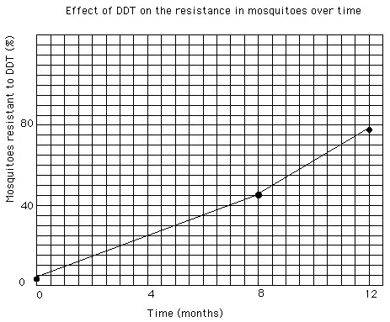

*Title (1)*

*X axis label (1)*

*Y axis label (1)*

*Appropriate scale on both axes (1)*

*Points plotted appropriately (1)*

(b) (i) What percentage of mosquitoes would you expect to be resistant to DDT at four

months ? (1 mark)

*25% (1)*

(ii) Explain why this is a reliable estimate. (1 mark)

*The estimate occurs within two known data points / is an example of interpolation (1)*

(c) Explain why genetic variation within a population is necessary for evolution.

(2 marks)

*genetic variation ensures that some individuals contain alleles/characteristics that provide a selective advantage for survival (1)*

*over time these characteristics become more common in the population so the population becomes better suited to the environment in which it finds itself (1)*

(d) What factors can produce genetic variation among populations? (3 marks)

*sexual reproduction / meiosis / fertilisation / mutation / random mating / isolation / migration / random genetic drift / founder effect (Any 3, 1 mark each)*

**Question 40. (9 marks)**

You hope to study a gene that codes for a neurotransmitter in human brain cells. You know the amino acid sequence of the protein.

(a) Name the procedure you would need to undertake in order to produce: (2 marks)

(i) multiple copies of the gene to study.

*polymerase chain reaction / PCR (1)*

(ii) a quantity of the neurotransmitter for evaluation as a potential medication.

*genetic engineering (1)*

(b) Describe the procedure you would use to produce multiple copies of the gene. (6 marks)

*(Any 6, 1 mark each)*

*DNA is denatured at 96OC (1)*

*so the double helix separates into two single strands (1)*

*The DNA is then cooled down to 50-65OC (1)*

*Primers are added to the DNA (1)*

*The mixture is raised back up to 72OC (1)*

*when DNA / Taq polymerase is added (1)*

*which builds a copy of each of the two single DNA strands (1)*

*This is repeated a number of times (1)*

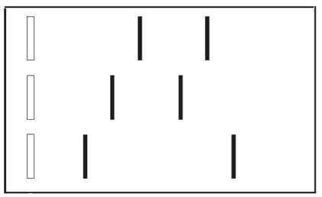(c) Recently, two couples in the same hospital in Korea each gave birth to a child on the same day. Three months later one couple returned to the hospital concerned that the child wasn’t theirs. The DNA test for this couple and the chid they were given is shown below.

Father

Mother

Baby

(i) Explain why this child does not belong to this couple. (1 mark)

*None of the bands of DNA have come from either the mother or father (1)*

**End of Section Two**

Section Three: Extended Answers (60 marks)

**Question 41. (20 marks)**

(a) A recent hominin skeletal find has contributed to our understanding of the theory of evolution in two ways: through fossil evidence and comparative anatomy. Discuss how these two pieces of evidence support the theory of evolution. (10 marks)

*Fossil evidence (Any 4 points, 1 mark each)*

*Fossil assemblage in various strata are different (1)*

*The further back in time, the simpler the fossil remains (1)*

*Some fossils are completely unlike any species alive today (1)*

*Many present day forms are not preserved in the fossil record and so presumably did not exist in the past (1)*

*When similarity exists between fossils and today’s species, the changing structure over time allows us to see the development of the species (1)*

*Comparative anatomy (Any 6 points, 1 mark each)*

*Involves comparing the structural similarity of related organisms to ascertain the degree of similarity between them (1)*

*The closer the relationship between the organisms being studied, the more similar they are (1)*

*This supports the idea of descent from a common ancestor (1)*

*Homologous structures are those that have a high degree of structural similarity although they may*

*perform different functions (1)*

*Eg: the vertebrate limb (1)*

*Vestigial structures are those that are believed to have been functional in our ancestors but have been retained in a rudimentary form (often reduced in size), and have no obvious function (1)*

*Eg: appendix, wisdom teeth, nictitating membrane, nipples in males, coccyx (1)*

(b) Muscle contraction is believed to occur due to a sliding filament model. Describe the sliding filament model of muscle contraction. (10 marks)

*(Any 10 points, 1 mark each – fully annotated diagrams are acceptable)*

*Myofibrils in muscle cells are organised into sarcomeres (1)*

*Each sarcomere is made up of actin and myosin filaments (1)*

*An action potential causes sodium to move into the muscle cell from the synapse due to gated channels opening (1)*

*The movement of sodium into the muscle cell causes calcium channels to open in the sarcoplasmic reticulum (1)*

*Calcium diffuses through the sarcoplasm and causes myosin to act like an enzyme (1)*

*Calcium binds to troponin / the actin filament which causes the tropomyosin to move / which exposes binding sites for attachment(1)*

*The myosin heads bind to the actin by forming cross bridges (1)*

*ADP and P are attached to the myosin head and the P is released (1)*

*Energy is used to move the myosin head causing the actin to slide past the myosin (1)*

*As a result, the sarcomere shortens and the muscle contracts (1)*

*ADP is released from the myosin head as it moves (1)*

*When the ATP binds to the myosin heads the myosin head is released from the binding site (1)*

*The myosin head returns to its upright position and can reattach to the actin again if calcium is still present (1)*

**Question 42. (20 marks)**

(a) With the extreme cold temperatures seen in some parts of Europe recently, regulation of body temperature can become a matter of life and death, especially for the aged. Explain how human bodies typically act to maintain core body temperature under cold conditions, both physiologically and behaviourally. (12 marks)

*(Any 10 points, 1 mark each)*

*Stimulus – decreased core body temperature (1)*

*Receptor – thermoreceptors in the hypothalamus / skin (1)*

*Modulator – hypothalamus (1)*

*Which releases TSHrf (1)*

*Which causes the anterior pituitary to release TSH (1)*

*Which causes the thyroid to produce thyroxine (1)*

*Effector – all body cells (1)*

*Skeletal muscle cells (1)*

*Smooth muscle of arterioles (1)*

*Response – increased rate of cell respiration (1)*

*Shivering (1)*

*vasoconstriction (1)*

*Feedback – increased core body temperature (1)*

*(Any 2 points, 1 mark each)*

*Behavioural mechanisms – put on clothing / consume hot food or drink / put on a heater / reduce surface area by curling into a ball etc*

(b) In 1775, a typhoon reduced the population of Pingelap, an island in Micronesia from 2000 to 20. Among the survivors was a person heterozygous for achromatopsia, an inherited form of total colour blindness. Describe how and why the gene pool of this population would have been affected by this event over time if this is an isolated population. (4 marks)

*(Any 4 points, 1 mark each)*

*Founder effect would have occurred as the population is now reduced to only 20 / very small (1)*

*This small population is not representative of the original population of the island (1)*

*Random genetic drift is a non-directional change in allele frequency (1)*

*which means by chance some alleles / achromatopsia allele becomes more common (1)*

*Achromatopsia would become more common over time (1)*

*A lack of immigration means that the population could only breed within this group (1)*

(c) Describe how bone cells and cartilage cells are supplied with their requirements.

(4 marks)

*(Any 4 points, 1 mark each)*

*Bone cells are supplied with oxygen / glucose / their requirements by blood vessels in the Haversian*

*systems (1)*

*and canaliculi (1)*

*oxygen / glucose / their requirements then diffuse out to the cells in the lacunae (1)*

*Cartilage cells lack a blood vessel supply (1)*

*So rely on diffusion over distance (1)*

**Question 43. (20 marks)**

(a) A recent fossil find showed that some hominins hafted their tools – they attached wooden handles to some of the bone hand axes they utilised for a variety of tasks. Fluorine dating was utilised in an attempt to date that tool and others found at the same site. Briefly explain how fluorine dating is carried out and identify any limitations it may have. (7 marks)

*(Any 3 points, 1 mark each)*

*Flouride ions are present in the water found in soil (1)*

*Over time, bone absorbs the fluorine from the water in the soil in which it sits (1)*

*The more fluorine a specimen has the older it is (1)*

*Limitations - (Any 4 points, 1 mark each)*

*Can only be used on bone (1)*

*Can only be used on samples from the same site (1)*

*as fluorine levels can vary in the soil from place to place (1)*

*and in one place over time (1)*

*can only provide a relative date (1)*

(b) Both the nervous and endocrine systems are used in the human body as a form of communication. Describe three ways in which their functioning differs. (3 marks)

*(Any 3 points, compared, 1 mark each)*

|  |  |  |
| --- | --- | --- |
|  | *Nervous system* | *Endocrine system* |
| *Mode of transmission* | *electrochemical* | *chemical* |
| *Specificity* | *Very specific / localised* | *Not very specific / widespread* |
| *Speed of transmission* | *fast* | *Slow* |
| *Response time* | *fast* | *Slow* |
| *Persistence* | *short* | *long* |

(c) Humans are classified as both primates and hominins. Describe the features that place us in each of these groups. (10 marks)

|  |  |
| --- | --- |
| *Primate characteristics*  *(Any 5 points, 1 mark each)* | *Hominin*  *(Any 5 points, 1 mark each)* |
| *large cerebral cortex* | *larger cerebral cortex* |
| *reduction in olfactory capabilities* | *bipedal* |
| *increase in optical capabilities / stereoscopic*  *vision / colour vision* | *reduction in prognathism* |
| *increase in gestation time* | *parabolic dentition / teeth similar in size and*  *shape* |
| *increase in parental care* | *S shaped spine* |
| *increased mobility of the digits / greater*  *opposability of the thumb / friction ridges /*  *nails instead of claws* | *pelvis broad and bowl shaped* |
| *teeth shape now a 4 cusp or Y5 pattern* | *Longitudinal and transverse arches in the foot* |
| *reduced number of teeth* |  |

**End of Questions**